SECTION-1 (HTML assignments)

1. Create an empty directory ‘Assignments’ & cd to ‘Assignments’.

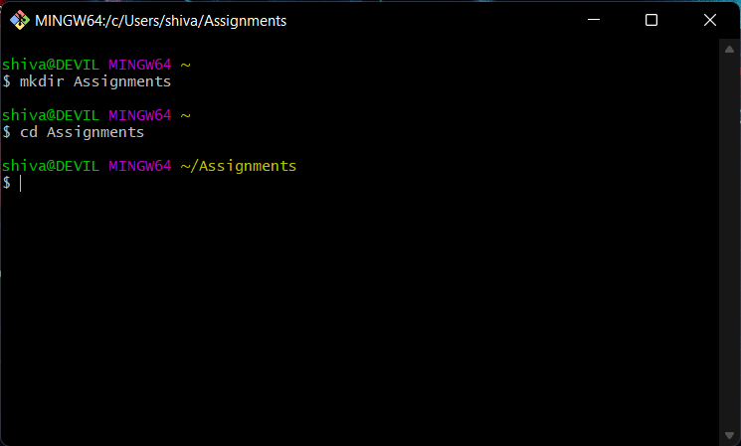

1. Create a file README.txt inside ‘Assignments’ & write few lines about the contents of ‘Assignments’ folder.

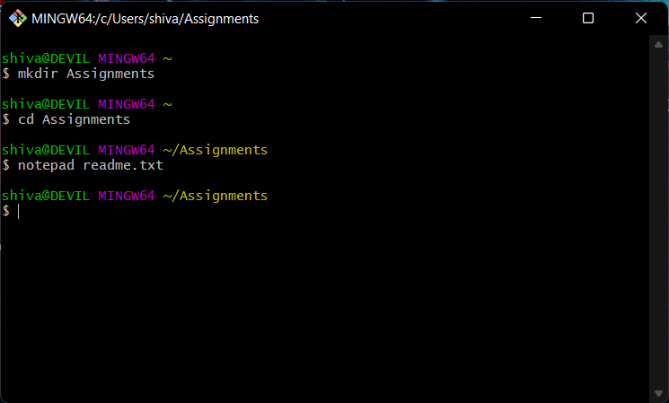

1. Commit README.txt file.

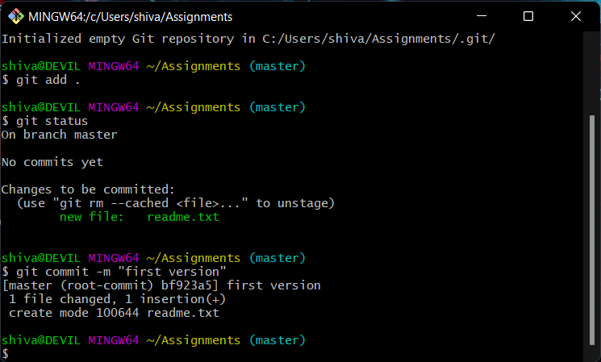

1. Now create a new branch ‘html-assignments’.

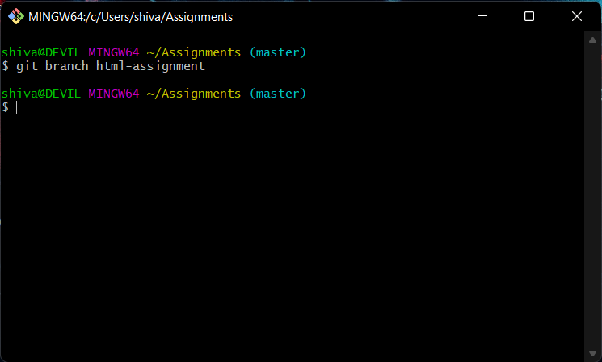

1. Switch to ‘html-assignments’ branch.

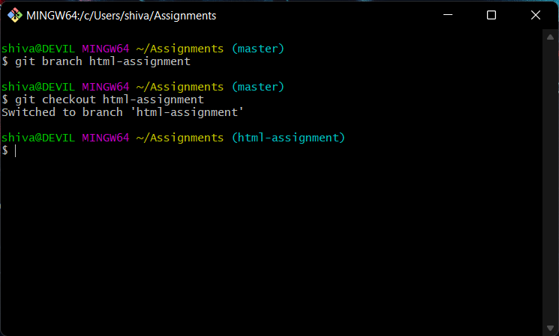

1. Copy all HTML assignments inside ‘Assignments’ folder.

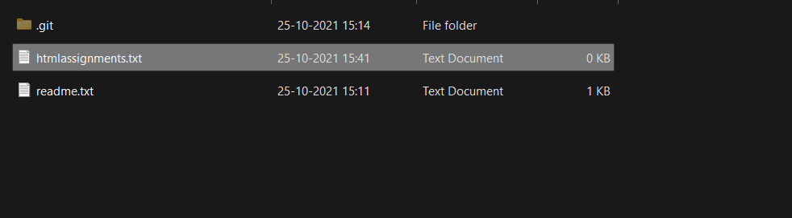

1. Commit HTML assignments into ‘html-assignments’ branch.

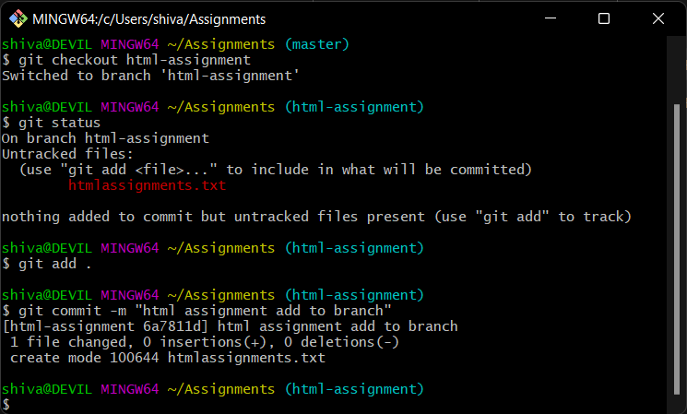

1. Make minor changes into few files belonging to ‘html-assignments’ branch.

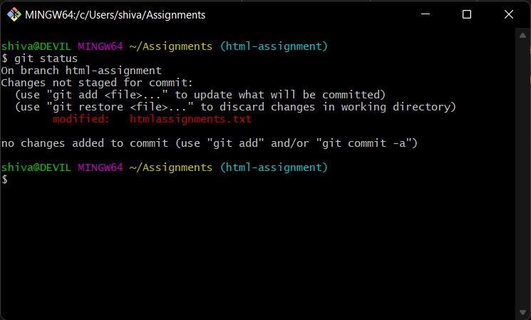

1. Commit those changed files.

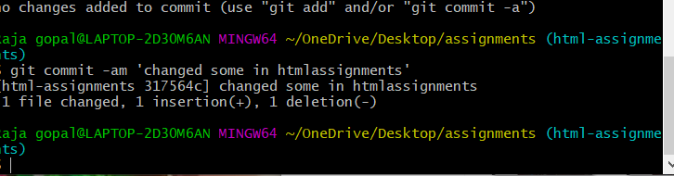

1. Switch to master branch.

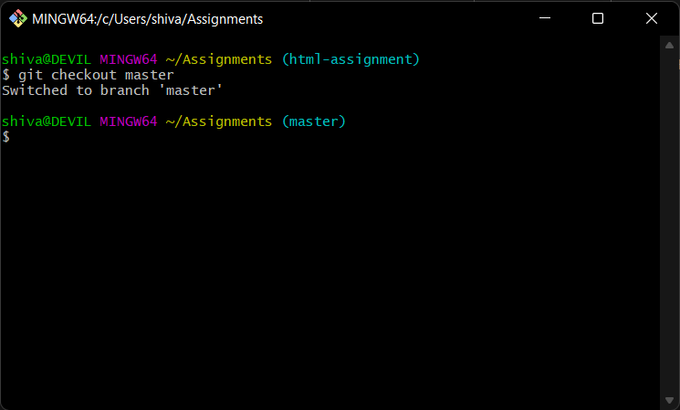

1. Make minor changes into README.txt file & commit those changes into master.

Done

Just screenshort deleted

1. Again switch to ‘html-assignments’ branch.

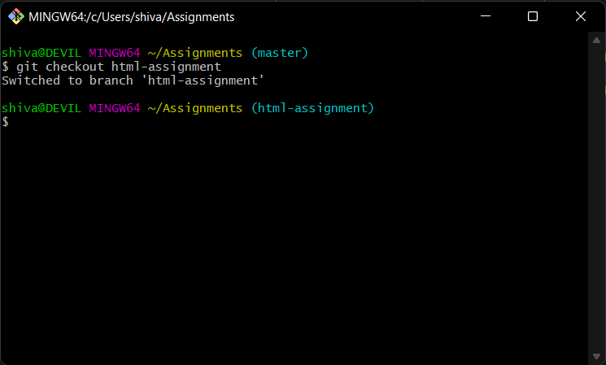

1. Make minor changes into few files belonging to ‘html-assignments’ branch.

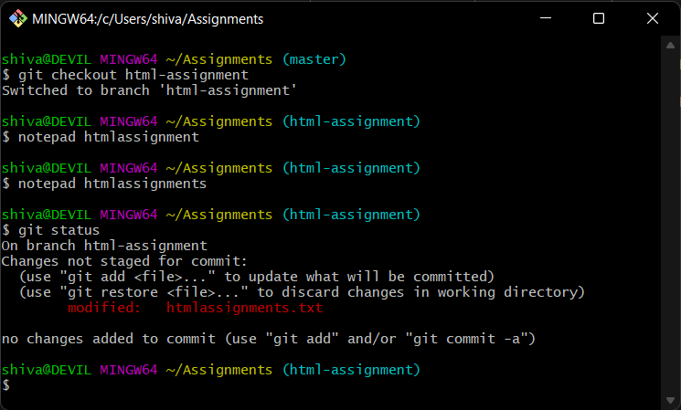

1. Commit those changes.

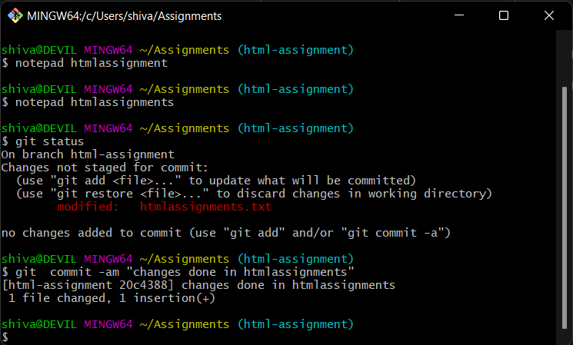

1. Switch to master.

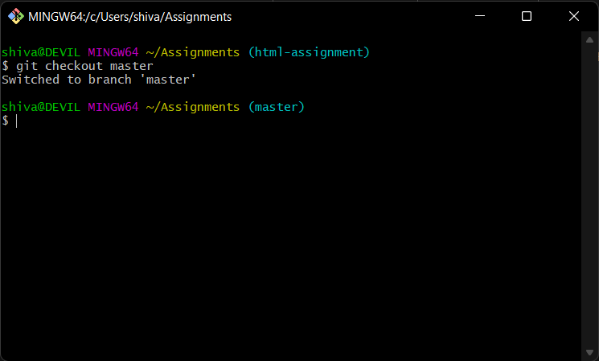

1. Merge ‘html-assignments’ branch into master. Confirm all html assignments are shown in master.

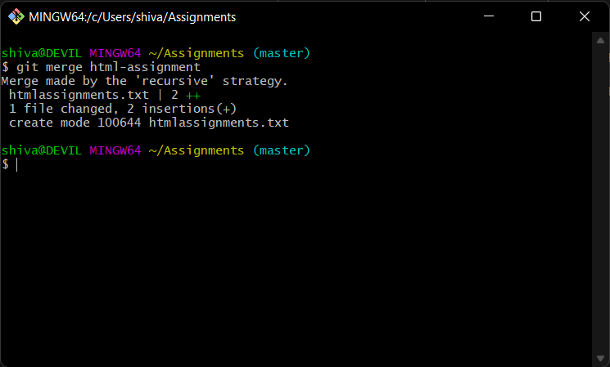

1. Finally delete the ‘html-assignments’ branch.

